

**ADAN BIN WAHEED**

**45426**

**OOP – LAB TASK 4 (REPORT)**

**TYPES OF INHERITANCE**

1. **SINGLE INHERITANCE:**

Single inheritance is a concept in OOP. Where a class can inherit properties and attributes from only one base class. Public members of a class are accessible from anywhere in the program. When a class is inherited using single inheritance and the public specifier is used, the public members of the base class become public members of the derived class. Private members are only accessible with in class. Protected members of a class are accessible within the class, its derived classes, and its friend functions.

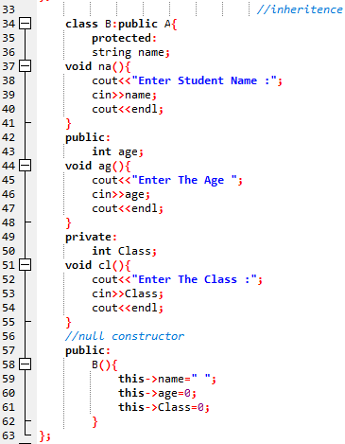

1. **MULTIPLE INHERITANCE:**

Multiple inheritance allows a class to inherit from multiple base classes. The private data members can only access by their respective classes. Protected members of base class can only access within class by derived class. Public members and function k easily accessible in the main by using derived class object.

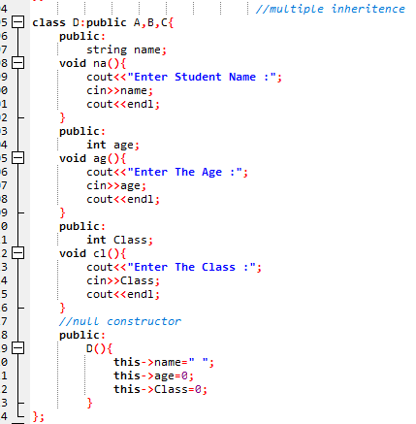

1. **Multilevel inheritance**

Multilevel inheritance is the process of deriving a class from another derived class, which is itself derived from a base class. In multilevel inheritance, a derived class inherits the properties of its parent class, which in turn inherits properties from its own parent class. Private members and functions of base, derived class, sub derived class can be accessed by their respective class. Public members of base and derived class can be accessed in main. Protected members of base class can be accessed by derived class within the class.

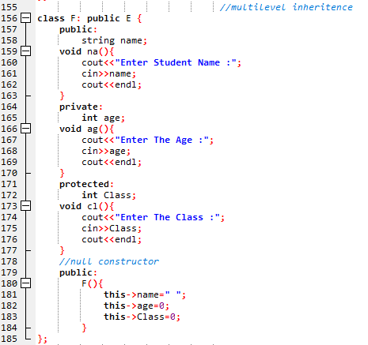

1. **HYBRID INHERITANCE**

Private members and functions of base, derived class, sub derived class can be accessed by their respective class. Protected members of base class can be accessed by derived class within the class and sub derived class can access the protected members of his parent class. Public members of base and derived class can be accessed in main function with the object of derived class.

